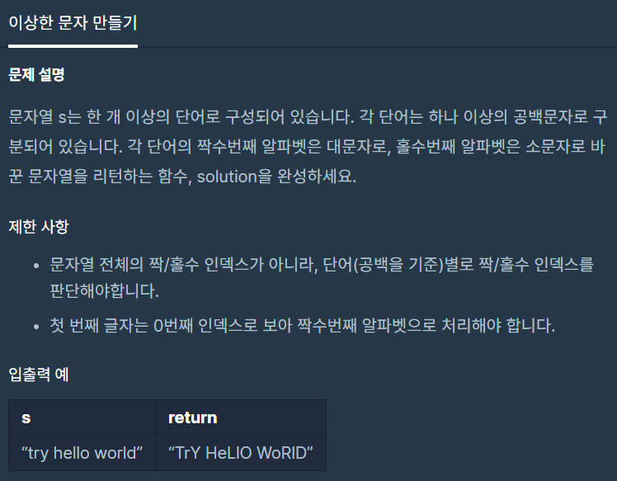

**문제 링크주소 :** <https://programmers.co.kr/learn/courses/30/lessons/12930>

**풀이**

function solution(*s*) {

    var answer = [];

    var arr=[];

    var arr2=[];

    arr.push(*s*.split(" "));

    for(var j=0; j<arr[0].length; j++){

        for(var i=0; i<arr[0][j].length; i++){

            if(arr[0][j].charCodeAt(i)>=97){

                if(i%2 ==1){

                    arr2.push(arr[0][j].charCodeAt(i));

                }else{

                    arr2.push(arr[0][j].charCodeAt(i)-32);

                }

            }

            else{

                if(i%2 ==1){

                    arr2.push(arr[0][j].charCodeAt(i)+32);

                }else{

                    arr2.push(arr[0][j].charCodeAt(i));

                }

            }

        }

        arr2.push(32);

    }

    for(var k=0; k<arr2.length-1; k++){

        answer.push(String.fromCharCode(arr2[k]));

    }

    return answer.join("");

}